**MATH 245 Simulation Project : Part 2**

Javier Jesús Macossay-Hernández

**Task #1-**

%Task # 1

%part a

a = -0.0381;

b = 0.0128;

c = 0.000042;

d = 0.0115;

e = -0.029;

f = 0;

g = 0.0041;

h = 0;

i = -0.000042;

A = [a b c; d e f; g h i];

aEig = eig(A);

display(aEig);

%part b

newA = -0.0831;

B = [newA b c; d e f; g h i];

bEig = eig(B);

display(bEig);

>> Simulation_Project_Part_2_Task_1

aEig =

-0.0465

-0.0206

-0.0000

bEig =

-0.0857

-0.0264

-0.0000

**Task #2-**

%main task 2

tspan = [0 800];

init = [0,0,0];

[t,y]=ode45(@gtask2,tspan, init);

%plot

figure

plot(t,y(:,1),'--',t,y(:,2),'O',t,y(:,3),'*')

xlabel('Time (days)');

ylabel('Amount of Lead (micrograms)');

title('Task #2');

legend('Concentration of lead in the blood','Concentration of lead in soft tissues','Concentration of lead in the bones');

function dy = gtask2(t,y)

dy = [-0.0381*y(1)+0.0128*y(2)+0.000042*y(3)+62.5*step(t)-56*step(t-365)

0.0115*y(1)-0.029*y(2)

0.0041*y(1)-0.000042*y(3)];

end

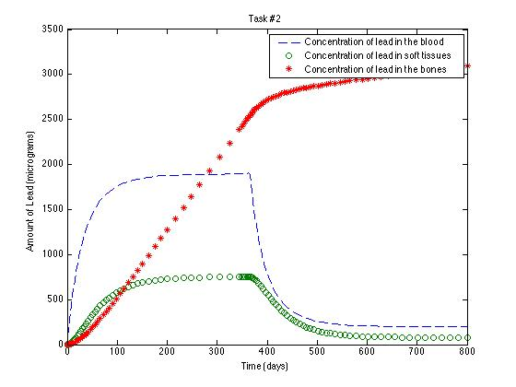

**Task #3-**

%main task 3

tspan = [0 800];

init = [0,0,0];

[t,y]=ode45(@gtask3,tspan, init);

%plot

figure

plot(t,y(:,1),'--',t,y(:,2),'O',t,y(:,3),'*')

xlabel('Time (days)');

ylabel('Amount of Lead (micrograms)');

title('Task #3');

legend('Concentration of lead in the blood','Concentration of lead in soft tissues','Concentration of lead in the bones');

function dy = gtask3(t,y)

dy = [(-0.0381*step(t)+0.0381*step(t-200)-0.0831*step(t-200)+0.0831*step(t-400)-0.0381*step(t-400))*y(1)+0.0128*y(2)+0.000042*y(3)+62.5*step(t)-62.5*step(t-400)

0.0115*y(1)-0.029*y(2)

0.0041*y(1)-0.000042*y(3)];

end

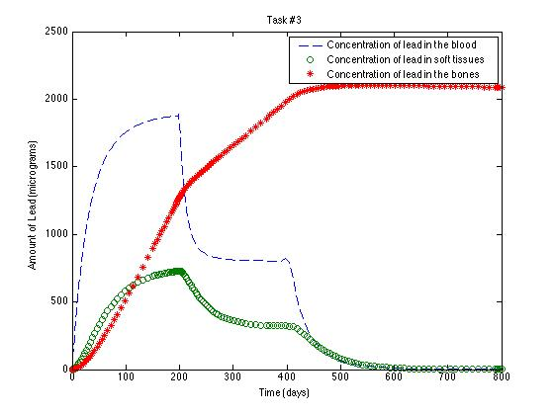

**Task #4-**

%main task 4

tspan = [0 1095];

init = [0,0,0];

[t,y]=ode45(@gtask4,tspan, init);

%plot

figure

plot(t,y(:,1),'--',t,y(:,2),'O',t,y(:,3),'*')

xlabel('Time (days)');

ylabel('Amount of Lead (micrograms)');

title('Task #4');

legend('Concentration of lead in the blood','Concentration of lead in soft tissues','Concentration of lead in the bones');

function dy = gtask4(t,y)

dy = [-0.0381*y(1)+0.0128*y(2)+0.000042*y(3)+40*(1+0.5*sin(2*pi*(t/365)))

0.0115*y(1)-0.029*y(2)

0.0041*y(1)-0.000042*y(3)];

end

